Architecture for the T-COM Network Software

# Condor Gao

Contents

Condor Gao 1

Introduction 3

Figure 1: Block Diagram Showing Major Communication Components in End-to-End System 3

# Introduction

The goal for T-COM network is to achieve a back to back connection from the device through the internet and to the cloud server. The data will be store in the database runs by the server and waiting for the further analysis.



Figure 1: Block Diagram Showing Major Communication Components in End-to-End System

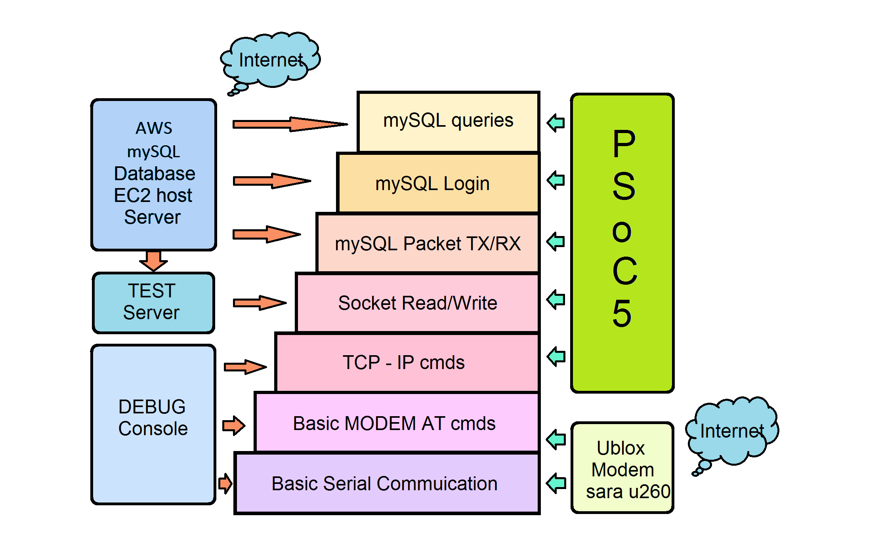

Figure 2: Wireless Cloud Communication Stack

# PHY/Datalink Layer

Serial communication with SARA MODEM

The PHY layer, from the standpoint of the MCU, involves serial data and handshake signals: TXD, RXD, RTS, CTS. Commands are based on an “AT” protocol, usually, command uses the syntax like:

AT+<cmd>=<values>

# Network/Session Layer

## Transport Control Protocol (TCP)

We need to emulate the socket library API calls, socket(), connect(), write(), and read().

### socket()

Create a socket:

AT+USOCR=<protocol>,<local_port> /r

Implemented using Ublox SARA U2 on T-COM as:

// PDP = Packet Data Protocol

// PSD = Packet Switched Data

send_at_cmd_txt( "CFUN", "1" ); // Set Module Functionality

// 1 (factory-programmed value): sets the MT to full functionality

send_at_cmd_txt( "UPSDA", "0,3" ); // Packet Switched Data Action

// PSD profile ID 0, 3: activate; it activates a PDP context with

// the specified profile, using the current parameters

send_at_cmd_txt( "USOCR", "6" ); // Create Socket, 6: TCP, 17: UDP

### connect()

Connect to a socket:

sprintf( cmd_str, "0,\"%d.%d.%d.%d\",%d", a,b,c,d,port );

// put cmd in one string<socket_id>,"<ip_addr>",<port>

send_at_cmd_txt( "USOCO", cmd_str); // Connect Socket to the server on a specific port

Note that <socket_id> is provided in response to AT+USOCR. And also when the socket is in use, the next USOCR will atomically create the socket using next slot (SARAu260 provide up to 7 slots).

### write()

#### Write socket data:

send_at_cmd_txt( "USOWR", "0,12,\"Hello World!\"" ); // params: <socket_id>,<num_bytes>,"<data>"

### read()

The Arduino Ethernet library has a call:

client->read();

which gets one byte from the socket stream.

It would be inefficient for us to issue AT+USORD for each byte. So, for example, to implement MySQL_Packet::read_packet()

Read socket data:

### AT+USORD=<socket>,<length>

Response:

### +USORD: <socket>,<length>,<data in the ASCII [0x00,0xFF] range>

### OK

Example:

AT+USORD=3,16

+USORD: 3,16,"16 bytes of data"

OK

# Glue Layer

int

wait_for_substr_or_error( char substr[], int timeout )

{

// If we encounter ERROR or timeout, then return a value of -1

// If we succeed, return value of 0

int substr_len;

int error_len;

int substr_match_idx;

int start_time;

int time_elapsed;

char err_str = "ERROR";

int err_idx;

uint8_t the_char;

char debug_str[256];

start_time = millis();

substr_len = strlen( substr );

sprintf( debug_str, "start_time=%d, timeout=%d, waiting for %d OKs\n", start_time, timeout, n );

UART_DEBUG_PutString( debug_str );

do

{

time_elapsed = millis() - start_time;

while (UART_GetRxBufferSize() == 0) {} // wait until at least 1 char in UART buffer

the_char = UART_ReadRxData();

UART_DEBUG_PutChar( the_char );

if (the_char == substr[substr_match_idx])

++substr_match_idx;

else

substr_match_idx = 0;

if (the_char == err_str[err_idx])

++err_idx;

else

err_idx = 0;

} while (substr_match_idx < substr_len && time_elapsed < timeout && !error_flag);

if (time_elapsed >= timeout)

{

UART_DEBUG_PutString( "TIMEOUT!!!\n" );

return -1;

}

else return 0;

}

void

parse_usord_resp( int req_len, int *resp_len, uint8_t buffer[] )

{

// Wait for the string:

// +USORD:

// Wait for:

// <socket_num>,

// Wait for:

// <resp_length>,"

// Wait for:

// <# of bytes = resp_len>

// Wait for "

// Wait for OK

}

void

wait_until_at_least_n_bytes_in_stream( int n )

{

do

{

// Issue:

// AT+USORD=<socket>,0

//

// Parse response:

// get <# of bytes = resp_len>

} while (resp_len < n);

void MySQL_Packet::read_packet() {

byte local[4];

wait_until_at_least_n_bytes_in_stream( 4 );

issue_usord( 4, local ); // Get 4 bytes from the stream in local

}

// Get packet length

packet_len = local[0];

packet_len += (local[1] << 8);

packet_len += ((uint32_t)local[2] << 16);

bytes_received = 0;

do

{

req_len = min(MAX_PKT_LEN, packet_len);

wait_until_at_least_n_bytes_in_stream( req_len );

issue_usord( req_len, buffer + bytes_received ); // Get 4 bytes from the stream in local

bytes_received += req_len;

packet_len -= req_len;

} while (packet_len > 0);

# Database Access Layer

Describe MySQL API

Give examples of key subroutines.